29 Feb 2020

## Question 1: Hypothesis testing

In 1970, the US Congress instituted a random selection process for the military draft. All 366 possible birth dates were placed in plastic capsules in a rotating drum and were selected one by one. The first date drawn from the drum received draft number one, the second date drawn received draft number two, etc. Then, eligible men were drafted in the order given by the draft number of their birth date. In a truly random lottery there should be no relationship between the date and the draft number. Your task is to investigate whether or not the draft numbers were randomly selected. The draft numbers (Y=Draft_No) sorted by day of year (X=Day_of_year) are given in the file lottery.xls.

1. Make a scatterplot of Y versus X and conclude whether the lottery looks random.

RNGversion(min(as.character(getRversion()), "3.6.2"))  
  
library("readxl")  
lottery <- read_xls("../Data/lottery.xls")  
Y <- lottery$Draft_No  
X <- lottery$Day_of_year  
plot(X,Y, pch = 19, cex = 0.5)

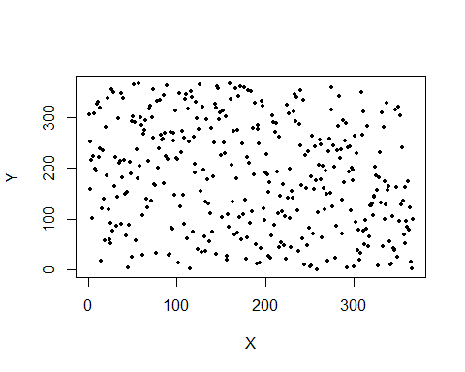 -

1. Compute an estimate $\hat{Y}$ of the expected response as a function of X by using a loess smoother (use loess()), put the curve $\hat{Y}$ versus X in the previous graph and state again whether the lottery looks random.

plot(X,Y, pch = 19, cex = 0.5)  
Y_hat <- loess(Y ~ X)$fitted  
points(X, Y_hat, col = "blue", pch = 19, cex = 0.5)

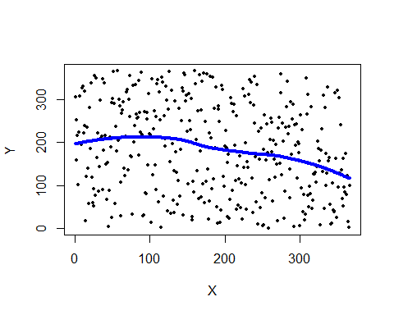 -

1. To check whether the lottery is random, it is reasonable to use test statistics
$$T=\frac{\hat{Y}(X_{b})−\hat{Y}(X_{a})}{X_{b}−X_{a}}, where X_{b}=argmax_{X}Y(X), X_{a}=argmin_{X}Y(X)$$

2. If this value is significantly greater than zero, then there should be a trend in the data and the lottery is not random. Estimate the distribution of T by using a non-parametric bootstrap with B = 2000 and comment whether the lottery is random or not. What is the p-value of the test?

T <- function(X,Y){  
 Xb <- X[which.max(Y)]  
 Xa <- X[which.min(Y)]  
 Y_Xb <- max(Y)  
 Y_Xa <- min(Y)  
  
 t <- (Y_Xb - Y_Xa) / (Xb - Xa)  
 return(t)  
}  
  
  
B <- 2000  
n <- dim(lottery)[1]  
tsamp <- rep(NA,B)  
set.seed(12345, kind="Mersenne-Twister", normal.kind="Inversion")  
for (i in 1:B){  
 mysample <- lottery[sample(n, size = n, replace = TRUE),]  
 X <- mysample$Day_of_year  
 Y <- loess(mysample$Draft_No ~ mysample$Day_of_year)$fitted  
 tsamp[i] <- T(X, Y)  
}  
hist(tsamp,breaks=100)

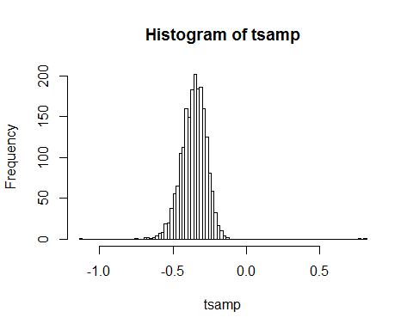

pvalue <- sum(tsamp > 0) / B  
pvalue

## [1] 0.001

1. Implement a function depending on data and B that tests the hypothesis $H_{0}$: Lottery is random versus $H_{1}$: Lottery is non-random by using a permutation test with statistics T. The function is to return the p-value of this test. Test this function on our data with B = 2000.

test_hypothesis <- function(data, B){  
 n <- dim(data)[1]  
 tx <- numeric(B)  
 set.seed(12345, kind="Mersenne-Twister", normal.kind="Inversion")  
 for (i in 1:B){  
 X <- sample(n, size = n, replace = TRUE)  
 Y <- loess(data$Draft_No ~ X)$fitted  
 tx[i] <- T(X, Y)   
 }  
 return(tx)  
}  
tx <- test_hypothesis(data = lottery, B = 2000)  
hist(tx,breaks=100)

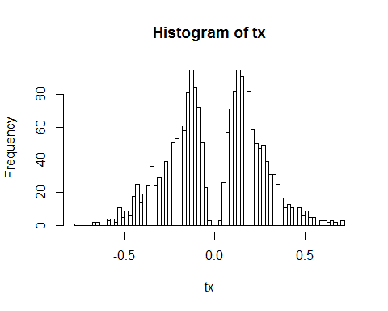

Y0 <- loess(lottery$Draft_No ~ lottery$Day_of_year)$fitted  
t0 <- T(lottery$Day_of_year, Y0)  
pvalue <- length(which(abs(tx) >= abs(t0))) / B  
pvalue

## [1] 0.1515

1. Make a crude estimate of the power of the test constructed in Step 4:
2. Generate (an obviously non-random) dataset with n = 366 observations by using same X as in the original data set and Y (x) = max(0, min($α$ x + $β$, 366)), where $α$ = 0,1 and $β ∼N(183,sd=10)$.
3. Plug these data into the permutation test with B = 200 and note whether it was rejected.
4. Repeat Steps 5a-5b for $α$ = 0.2,0.3,…,10.

What can you say about the quality of your test statistics considering the value of the power?

alpha <- seq(0.1, 10, 0.1)  
pvalues <- vector(length = length(alpha))  
for(j in 1:length(alpha)){  
 X <- lottery$Day_of_year  
 Y <- numeric(366)  
 for(i in 1:366){  
 beta <- rnorm(1, mean=183, sd=10)  
 YY <- min((alpha[j] * X[i] + beta), 366)  
 Y[i] <- max(0, YY)  
 }  
 newdata <- data.frame("Day_of_year" = X, "Draft_No" = Y)  
 tvec <- test_hypothesis(data = newdata, B = 200)  
 Y0 <- loess(Draft_No ~ Day_of_year, data = newdata)$fitted  
 t0 <- T(newdata$Day_of_year, Y0)  
 pvalues[j] <- mean(abs(tvec) > abs(t0))  
}  
length(which(pvalues < 0.05)) / 100

## [1] 1

## Question 2: Bootstrap, jackknife and condfidence intervals

The data you are going to continue analyzing is the database of home prices in Albuquerque, 1993. The variables present are Price; SqFt: the area of a house; FEATS: number of features such as dishwasher, refrigerator and so on; Taxes: annual taxes paid for the house. Explore the file prices1.xls.

1. Plot the histogram of Price. Does it remind any conventional distribution? Compute the mean price.

prices <- read_xls("../Data/prices1.xls")  
hist(prices$Price, breaks = 50)

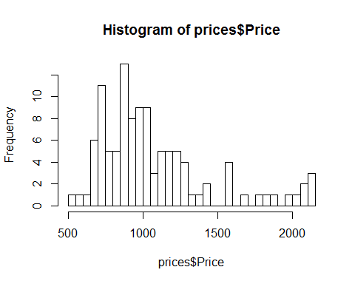

mean(prices$Price)

## [1] 1080.473

1. Estimate the distribution of the mean price of the house using bootstrap. Determine the bootstrap bias-correction and the variance of the mean price. Compute a 95% confidence interval for the mean price using bootstrap percentile, bootstrap BCa, and first-order normal approximation (**Hint**: use boot(),boot.ci(),plot.boot(),print.bootci())

library(boot)  
mymean <- function(data, ind){  
 mean(data[ind])  
}  
set.seed(12345, kind="Mersenne-Twister", normal.kind="Inversion")  
samples <- boot(data = prices$Price, statistic = mymean, R = 2000)  
  
plot(samples)

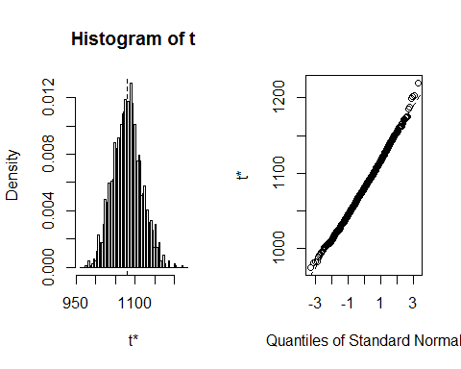

mean(samples$t)

## [1] 1080.265

bias_correction <- 2 * mean(prices$Price) - mean(samples$t)  
bias_correction

## [1] 1080.68

var(samples$t)[[1]]

## [1] 1284.346

conf_ints <- boot.ci(samples)  
conf_ints

## BOOTSTRAP CONFIDENCE INTERVAL CALCULATIONS  
## Based on 2000 bootstrap replicates  
##   
## CALL :   
## boot.ci(boot.out = samples)  
##   
## Intervals :   
## Level Normal Basic   
## 95% (1010, 1151 ) (1008, 1150 )   
##   
## Level Percentile BCa   
## 95% (1011, 1153 ) (1017, 1157 )   
## Calculations and Intervals on Original Scale

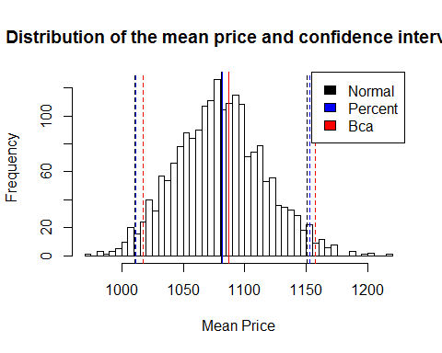

1. Estimate the variance of the mean price using the jackknife and compare it with the bootstrap estimate

Ti <- rep(NA, length(prices$Price))  
n <- length(prices$Price)  
for(i in 1:n){  
 jack <- prices$Price[-i]   
 Ti[i] <- n * mean(prices$Price) - (n-1) * mean(jack)  
}  
J_mean <- mean(Ti)  
J_mean

## [1] 1080.473

J_Var <- sum((Ti-J_mean)^2) / (n*(n-1))  
J_Var

## [1] 1320.911

1. Compare the confidence intervals obtained with respect to their length and the location of the estimated mean in these intervals.

## Appendix

knitr::opts_chunk$set(echo = TRUE, fig.align = "center", out.width = "70%")  
RNGversion(min(as.character(getRversion()), "3.6.2"))  
  
library("readxl")  
lottery <- read_xls("../Data/lottery.xls")  
Y <- lottery$Draft_No  
X <- lottery$Day_of_year  
plot(X,Y, pch = 19, cex = 0.5)  
plot(X,Y, pch = 19, cex = 0.5)  
Y_hat <- loess(Y ~ X)$fitted  
points(X, Y_hat, col = "blue", pch = 19, cex = 0.5)  
T <- function(X,Y){  
 Xb <- X[which.max(Y)]  
 Xa <- X[which.min(Y)]  
 Y_Xb <- max(Y)  
 Y_Xa <- min(Y)  
  
 t <- (Y_Xb - Y_Xa) / (Xb - Xa)  
 return(t)  
}  
  
  
B <- 2000  
n <- dim(lottery)[1]  
tsamp <- rep(NA,B)  
set.seed(12345, kind="Mersenne-Twister", normal.kind="Inversion")  
for (i in 1:B){  
 mysample <- lottery[sample(n, size = n, replace = TRUE),]  
 X <- mysample$Day_of_year  
 Y <- loess(mysample$Draft_No ~ mysample$Day_of_year)$fitted  
 tsamp[i] <- T(X, Y)  
}  
hist(tsamp,breaks=100)  
  
pvalue <- sum(tsamp > 0) / B  
pvalue  
test_hypothesis <- function(data, B){  
 n <- dim(data)[1]  
 tx <- numeric(B)  
 set.seed(12345, kind="Mersenne-Twister", normal.kind="Inversion")  
 for (i in 1:B){  
 X <- sample(n, size = n, replace = TRUE)  
 Y <- loess(data$Draft_No ~ X)$fitted  
 tx[i] <- T(X, Y)   
 }  
 return(tx)  
}  
tx <- test_hypothesis(data = lottery, B = 2000)  
hist(tx,breaks=100)  
  
Y0 <- loess(lottery$Draft_No ~ lottery$Day_of_year)$fitted  
t0 <- T(lottery$Day_of_year, Y0)  
pvalue <- length(which(abs(tx) >= abs(t0))) / B  
pvalue  
alpha <- seq(0.1, 10, 0.1)  
pvalues <- vector(length = length(alpha))  
for(j in 1:length(alpha)){  
 X <- lottery$Day_of_year  
 Y <- numeric(366)  
 for(i in 1:366){  
 beta <- rnorm(1, mean=183, sd=10)  
 YY <- min((alpha[j] * X[i] + beta), 366)  
 Y[i] <- max(0, YY)  
 }  
 newdata <- data.frame("Day_of_year" = X, "Draft_No" = Y)  
 tvec <- test_hypothesis(data = newdata, B = 200)  
 Y0 <- loess(Draft_No ~ Day_of_year, data = newdata)$fitted  
 t0 <- T(newdata$Day_of_year, Y0)  
 pvalues[j] <- mean(abs(tvec) > abs(t0))  
}  
length(which(pvalues < 0.05)) / 100  
prices <- read_xls("../Data/prices1.xls")  
hist(prices$Price, breaks = 50)  
  
mean(prices$Price)  
library(boot)  
mymean <- function(data, ind){  
 mean(data[ind])  
}  
set.seed(12345, kind="Mersenne-Twister", normal.kind="Inversion")  
samples <- boot(data = prices$Price, statistic = mymean, R = 2000)  
  
plot(samples)  
  
mean(samples$t)  
bias_correction <- 2 * mean(prices$Price) - mean(samples$t)  
bias_correction  
  
  
var(samples$t)[[1]]  
  
conf_ints <- boot.ci(samples)  
conf_ints  
hist(samples$t, main="Distribution of the mean price and confidence intervals", xlab="Mean Price", breaks = 50)  
abline(v = conf_ints$normal[2:3],   
 col = "black",   
 lty = "dashed",   
 lwd = 1.5)  
abline(v = mean(conf_ints$normal[2:3]),   
 col = "black",   
 lwd = 1.5)  
abline(v = conf_ints$percent[4:5],   
 col = "blue",   
 lty = "dashed",   
 lwd = 1.5)  
abline(v = mean(conf_ints$percent[4:5]),   
 col = "blue",   
 lwd = 1.5)  
abline(v = conf_ints$bca[4:5],   
 col = "red",   
 lty = "dashed",   
 lwd = 1.5)  
abline(v = mean(conf_ints$bca[4:5]),   
 col = "red",   
 lwd = 1.5)  
legend(x = "topright",   
 legend = c("Normal", "Percent", "Bca"),   
 fill = c("black", "blue", "red"))  
Ti <- rep(NA, length(prices$Price))  
n <- length(prices$Price)  
for(i in 1:n){  
 jack <- prices$Price[-i]   
 Ti[i] <- n * mean(prices$Price) - (n-1) * mean(jack)  
}  
J_mean <- mean(Ti)  
J_mean  
J_Var <- sum((Ti-J_mean)^2) / (n*(n-1))  
J_Var